**CSCD 240  
Lab 1**

**NOTE: Capture means copy and paste from a command line into a text editor. “Capture command xyz” means to capture the xyz command AND its resulting output.**

**NOTE: The lab must be completed on Cslinux machine by using remote login**

1. Capture the results of the uname –a command. What is the purpose of the uname command? How did you find information on the uname command?
2. Capture a detailed list of ALL files and directories, including dot files, in the /lib directory.  By editing your text file, indicated which lines refer to: files, directories and links. – You don’t need to do this for all the files, just a few to illustrate you understand the difference. (2 of each)
3. Capture the command and a detailed listing of the file properties of the .bashrc file in your home directory. Add a comment below this capture that explains all the file properties of .bashrc.
4. Create a subdirectory called cscd240 in your home directory. Capture the command that created the directory and the output of an ls command that shows that the new directory exists.
5. Create another subdirectory inside cscd240 that is named lab1. Capture the command that created the directory and the output of an ls command that shows that the new directory exists. NOTE: The creation of the directory lab1 must be made from /home/EASTERN/yourhomedirectory
6. With the home directory still as your current working directory, capture the command that copies the .bashrc file from your home directory to a file called copy.bashrc in the lab1 directory.
7. Within the home directory, capture a detailed listing of all the files in the lab1 directory.
8. Change to the lab1 directory capture the change directory command and capture a command that renames the copy.bashrc in lab1 to my.copy.bashrc.
9. Capture a detailed listing of all the files in the lab1 directory.
10. Starting in your lab1 directory, capture a command that uses a relative pathname to make cscd240 the current working directory.
11. Use the **pwd** command to indicate the current working directory.
12. Starting in /usr/bin, (you will have to change to /usr/bin) (Prove you are in /usr/bin with pwd) capture the command using an absolute path that will make your home directory the current working directory. Prove the directory change with pwd.

1. Capture the command and output using **rmdir** (with no other commands) to delete the lab1 subdirectory. Does it delete the directory? Why or why not?
2. Change directory so you are working from within the lab1 directory. Once in the directory:
   1. Capture the command that will create 6 files using the **touch** command. The files will be named test, test1, test21, test3, something, nothing.
   2. Capture the use NANO to add text to the file test1. ( hint: nano file_name )
   3. Capture the long listing of test1 to show the size changed.
3. Capture the command to create a tar file named files.tgz that contains all the files from #14. Capture the ls command to show the tar file was created. (Hint **tar** command)
4. Capture the command echo $PS1.
   1. Capture the command PS1=”prompt : ”
   2. Explained what happened

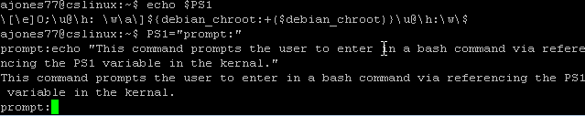

1. Capture the **df** command
   1. What is the purpose of the df command?
   2. Capture the df command that allows the output in human readable format
2. Change directory into your lab1 directory again, make a new file called rules.log. Then using ‘ls –al’ to find the permission for this rules.log file. Explain the permission of this file for the owner, group and other users in the system. Find which group does your account belongs to? Capture all above activity and results in your terminal.
3. Change directory into lab1 directory, and make a new subdirectory named test_code.
4. Using cd .. to go into lab1’s parent directory. Then capture the results of making a copy of lab1 directory, including all its subdirectories, named as lab1.copy.
5. Go into lab1.copy and run command rm *, explain what you get after run this command.
6. Make a new command dir that is equivalent to linux command ‘ls –alh’, when type dir in your terminal, the shell will actually run ‘ls –alh’. Capture the command that can achieve that and the results.

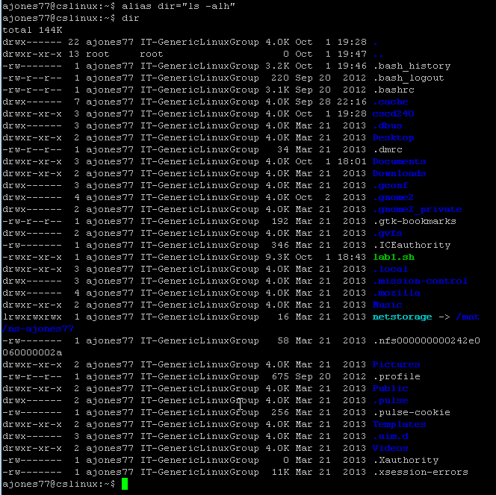

1. We like to get a warning or prompt information before we delete the rules.log file in lab1 folder. Find out that command and capture the results.
2. With your regular account, change directory to /usr directory and try to create a new folder called junk. Are you able to create this new folder? Capture the command and the execution results. Explain Why or Why not successful?

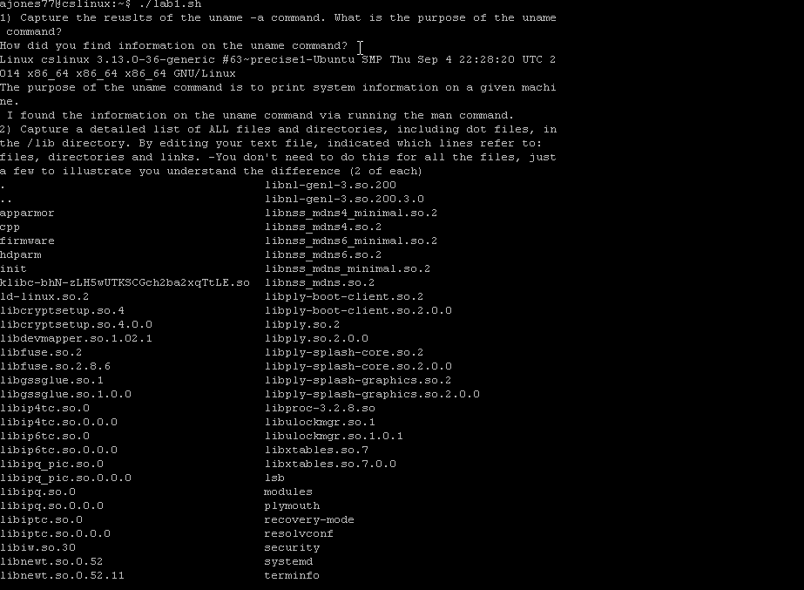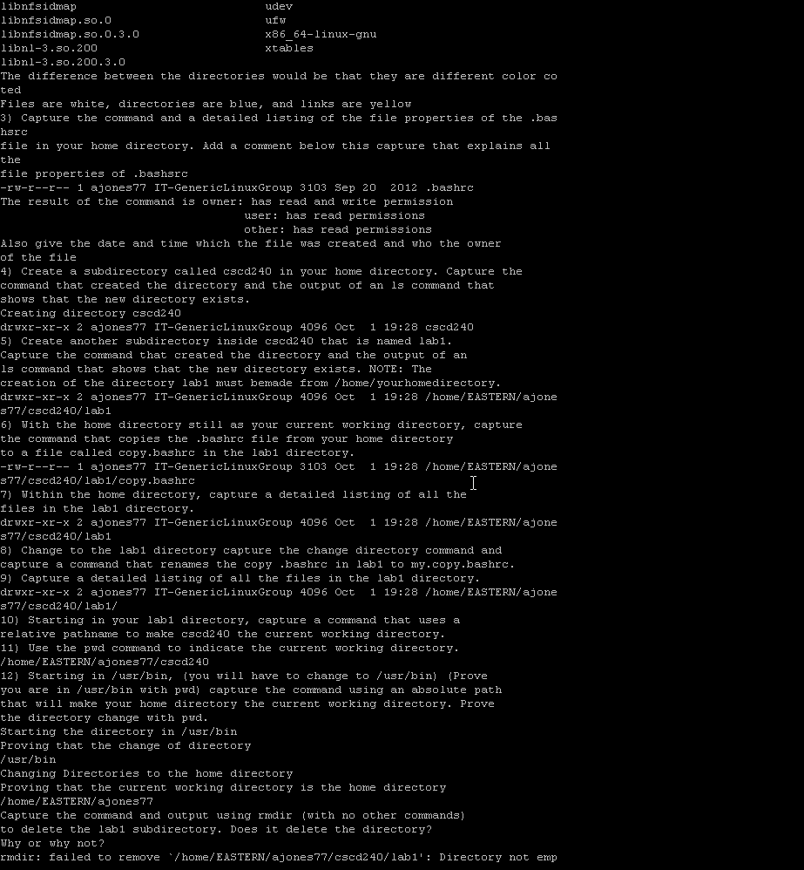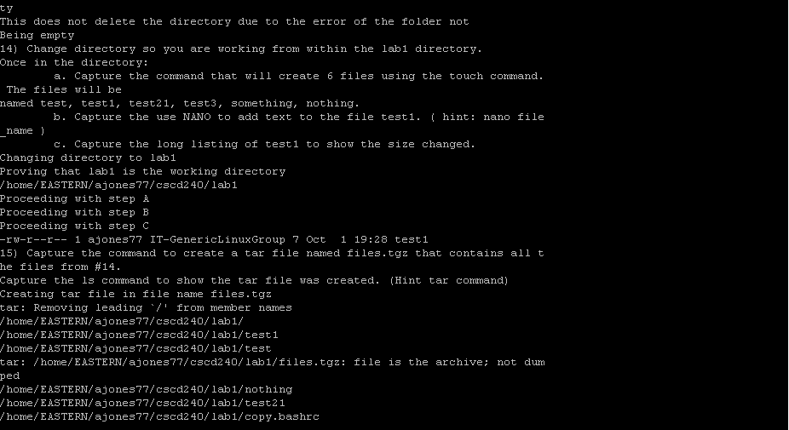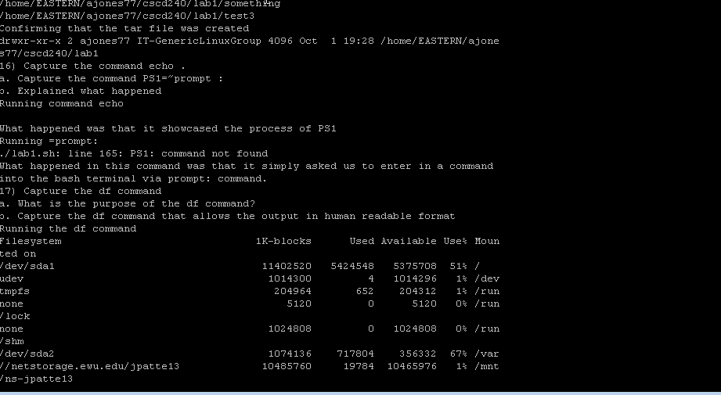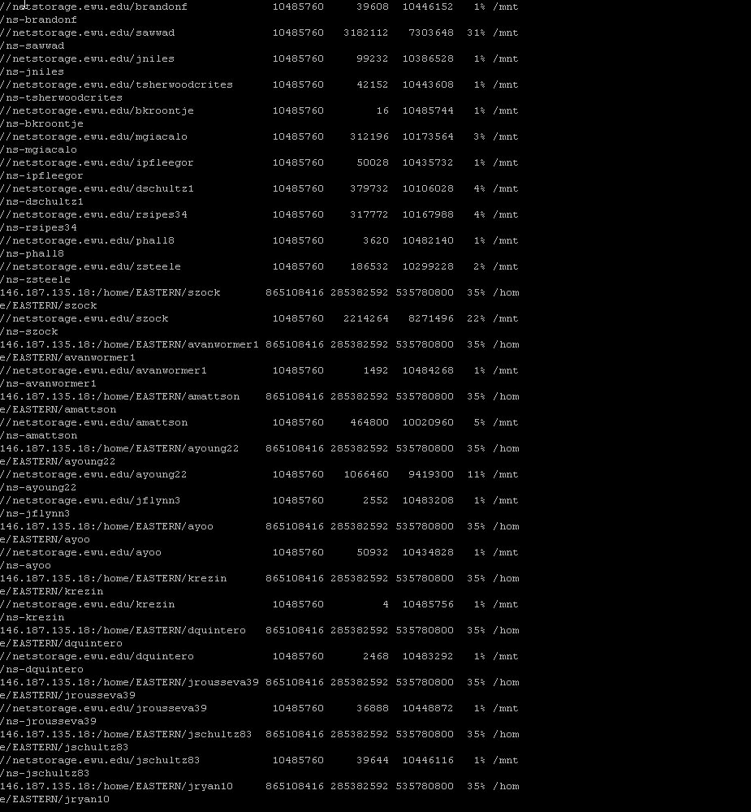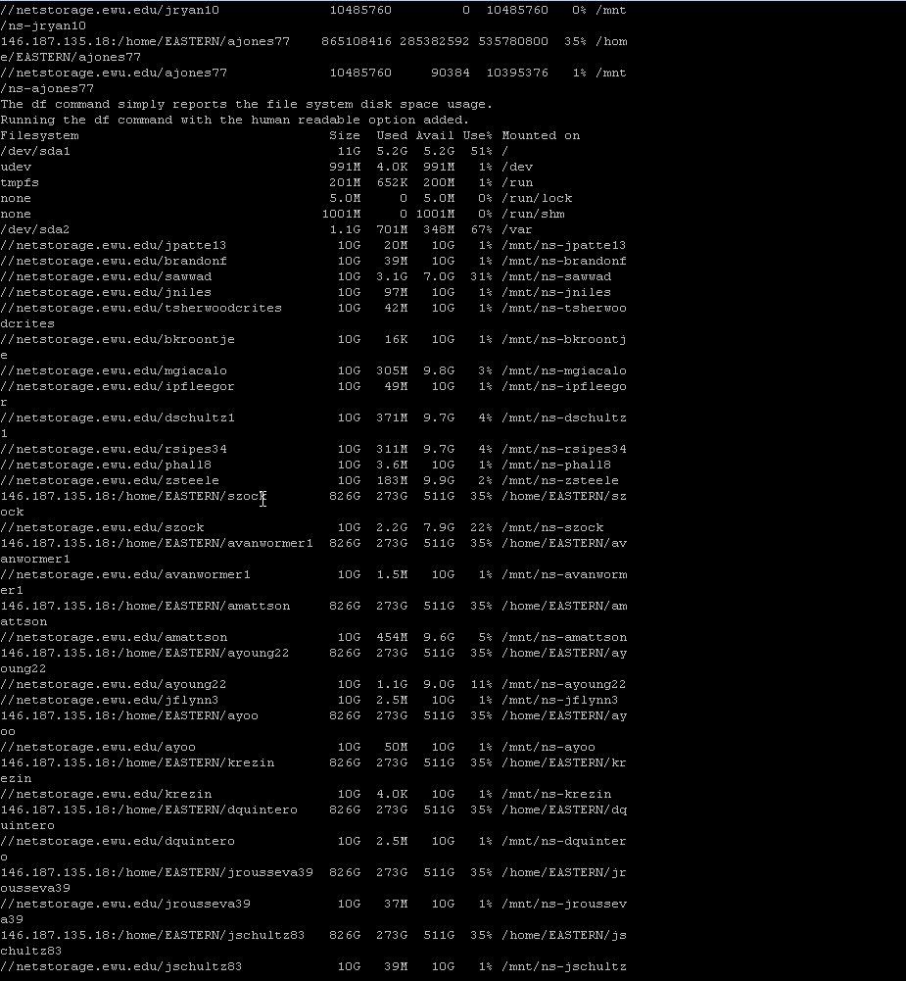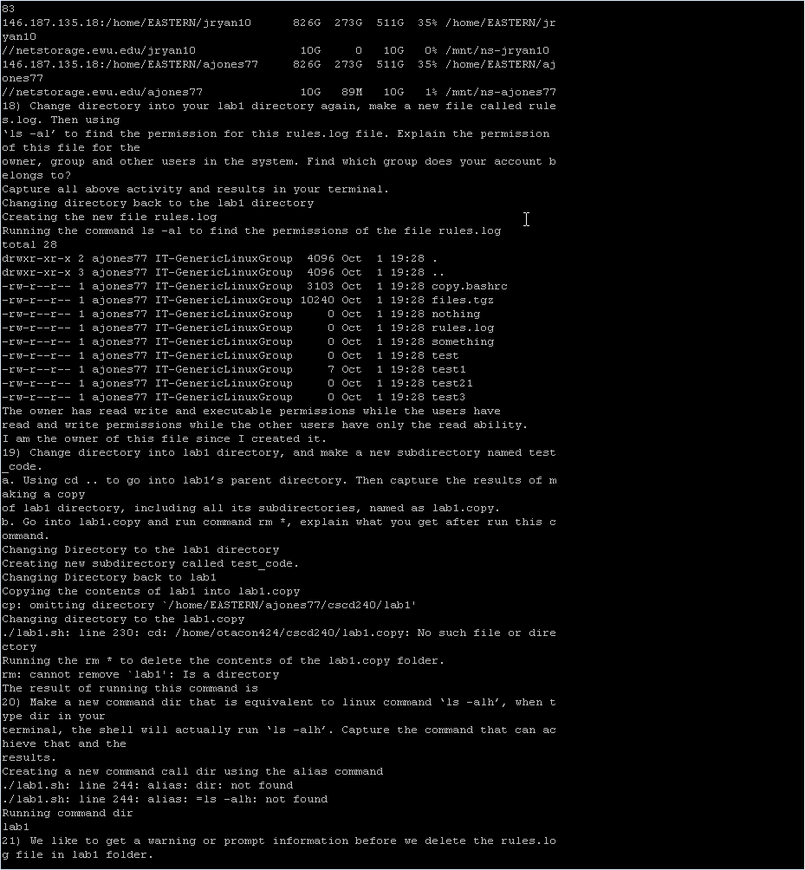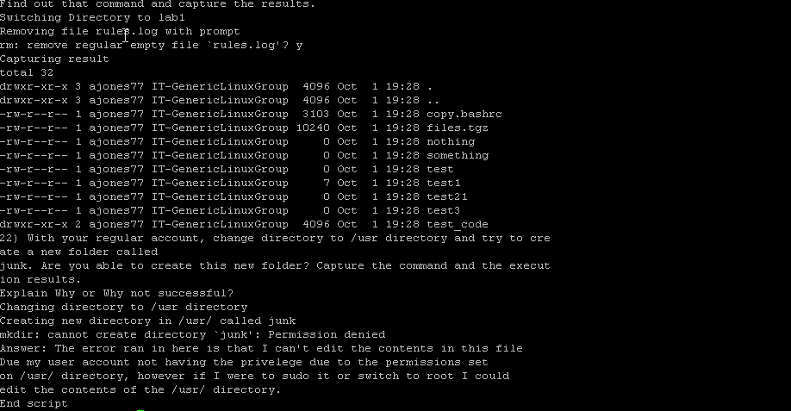

Note: Ran all the given commands via a script that will be attached to this assignment as well. The only commands that I had issues with were on question 16 and 20. Which I’ll be adding their pictures in separately within the question.

**TO TURN IN:**

* **A PDF file** - Name this file your last name then followed by first letter of your first name lab1.pdf. This file will contain all your answers. E.g. for John Smith, your file name is smithjlab1.pdf.
* **I would like the question copied and then the answer to the question below it.**
* A zip file that contains your pdf, your tar file from #15.
* You could capture a screen using screen shot in windows OS.
* You should turn in through the EWU Canvas. Go to EWU Canvas 2014 CSCD240 🡪 Assignments 🡪 Lab1 🡪 Submit Assignment, then you can choose your zip file to upload.

Your zip will be named your last name first letter of your first name lab1.zip (example smithjlab1.zip)

NOTE: Please only submit a single zip file.